Block Specification
bias_card - top level

Rev. | Date | Description of change
1 | 4 October 2005 | Initial release
1.1 | 2007-08-02 | Added doc number, rev. history  Added slot_id, bc_pll, list of commands parsed by bias card  updated diagrams

Table of Contents
1. Block Description 2
1.1 Block Hierarchy 2
1.2 Block Overview and Features 2
1.3 Detailed Description 2
2. Interface Description 5
2.1 Signals Description 5
Files Associated with this Block 7

Block Description
The bias_card is the top-level block in the hierarchy of the RTL-level code for the Bias-card FPGA.

Block Hierarchy
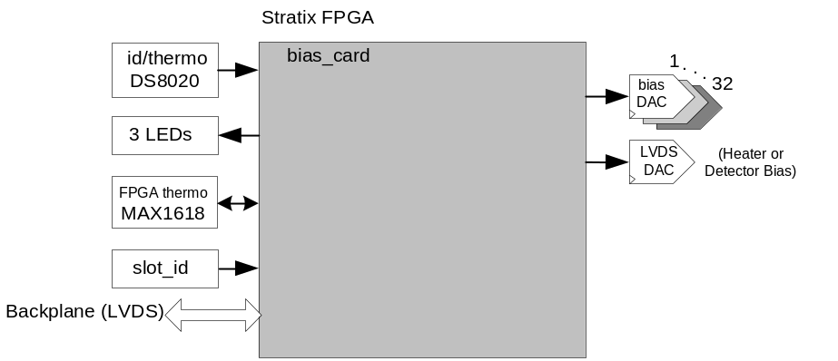
Figure 1 : bias_card: Block Location Within the System

Block Overview and Features
The bias_card top level communicates to the external devices including the 32 serial DACs , the LVDS DAC, LEDs, id/thermo chip, and EEPROM (not implemented). A PLL is also instantiated using one of the built-in Stratix PLLs to generate the necessary clocks for all blocks from an incoming 25MHz clock originated on the clock card and sent over the backplane (lvds_clk).
The main functionality of this firmware is to drive the digital serial peripheral interface (SPI) of the DACs. The SPI interface is a simple 3-wire interface: data, clk, ncs (chip select). These DACs are driven at 12.5MHz and 16 bits have to be clocked in to set the value of a DAC. Each DAC is individually controlled. Figure 2 shows the overall timing of the bias card operation.
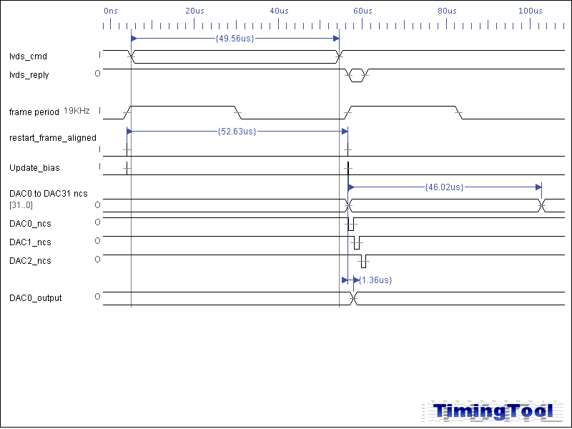
Figure 2: Timing diagram for DAC output update

Detailed Description
The Wishbone bus protocol (refer to Wishbone Specification) is adopted as inter-block communication standard between the different blocks in bias_card. One block, in this case dispatch, acts as Wishbone Master and the other blocks are Wishbone slaves. Commands are received along the backplane LVDS line, lvds_cmd, and then decoded by the Wishbone Master and communicated to the relevant Wishbone Slave through the Wishbone protocol. Then an acknowledgment reply is sent back over the backplane LVDS line, lvds_txa. Commands are of read/write form of a particular parameter in bias_card.
The Wishbone interface and timing is better described in “dispatch block description (SC2-ELE-S580-202)” document. Parameters decoded by the top-level are (as of bc firmware 3.0.7):
Parameter | Wishbone Slave | Description
flux_fb | bc_dac_ctrl | Takes 32 unsigned values between 0 to (2¹⁶-1) to load the 32 16b serial DACs. When out of range values are specified, the 16 lower bits are in effect.
bias | bc_dac_ctrl | Takes an unsigned value between 0 and (2¹⁶-1) to program the on-board LVDS DAC. When out-of-range values are specified, the 16 lower bits are in effect.
fpga_temp | fpga_thermo | Retrieve the FPGA silicon temperature through the on-board helper chip.
card_temp | id_thermo | Retrieve the card temperature from on-board DS8020
card_id | id_thermo | Retrieve the silicon ID from on-board DS8020
led | leds | Takes a 3b value to control/toggle the on-board LEDs. The specified value is XORed with current status of LEDs. Therefore, the result of writing 111 to this parameter may vary depending on what the current status of LEDs were at the time.
fw_rev | fw_rev | Returns a firmware revision where the format is RRrrBBBB  RR is the major revision number  rr is the minor revision number  BBBB is the build number
slot_id | slot_id | Returns the 4b ID of the particular slot the card is plugged into.
row_len | frame_timing | Specify number of 50MHz clock cycles per row
num_rows | frame_timing | Specifies number of rows
sample_dly | frame_timing | Optional (not used on bias_card)
sample_num | frame_timing | Optional (not used on bias_card )
fb_dly | frame_timing | Optional (not used on bias_card )
row_dly | frame_timing | Optional (not used on bias_card)
resync_addr | frame_timing | Optional (not used on bias_card)
flx_lp_init | frame_timing | Optional (not used on bias_card)
Table 1-1List of bias-card parameters
The following blocks are instantiated in bias_card block:
- bc_dac_ctrl:
  - A wishbone slave to control all the serial DACs and load the 16b values specified through a command. Upon receiving the command all values are registered and then loaded into the DACs one after next upon start of a data frame. The internal 50MHz clock is divided down by 4 to load the serial DACs at 12.5MHz. It takes 16 × 80ns = 1280ns to load each DAC and since they are loaded one after next, it takes 32 × 1280ns + 32 × 80ns (overhead) = 43.5µs to load all the DACs. See Figure 2 for timing information.
- frame_timing:
  - This block is instantiated on all cards, it controls the overall timing and ensures the coherence of the operations of the different blocks. In case of bias_card, it generates an update_bias signal to indicate the start of a frame after the command is received over the backplane. This signal is used to trigger the refresh of DACs by bc_dac_ctrl.
- dispatch:
  - Receives and decodes the incoming backplane commands
  - Delivers the wishbone-formatted command to the appropriate wishbone slave
  - Converts the wishbone reply to backplane format and transmits the reply over the backplane.
- id_thermo: A wishbone slave to read the card-id and the temperature from the DS8020 chip
- leds: A wishbone slave to controls the 3 LEDs.
- fw_rev: A wishbone slave to return the firmware revision
- fpga_thermo: A wishbone slave to return the FPGA silicon temperature through on-board MAX1618
- slot_id: A wishbone slave to return the 4-bit slot id.
- bc_pll: generates a 50MHz clock for FPGA operation, a 100MHz clock for 4× oversampling of incoming 25MHz command packets over lvds_cmd, and an absolute non-sense 180º shifted 50MHz.
For more information, refer to the documentation for each block.

bc_dac_ctrl
frame_timing
dispatch
bias_card
bc_dac_ctrl_core
bc_dac_ctrl_wbs
leds
fw_rev
id_thermo
fpga_thermo
slot_id
bc_pll

Figure 3: bias_card Block Diagram

Interface Description

Signals Description
 | Description | Direction
Global Signals
rst_n | Global reset signal | In
inclk | PLL input clock | in
Interface to 32 Bias DACs
dac_ data | 32-bit data for DAC0 to DAC31 with each bit being the serial data for one of the DACs | out
dac_sclk | 32-bit clock for DAC0 to DAC31 with each bit being the clock for one of the SPI DACs | out
dac_ncs | 32-bit chip select for DAC1 to DAC8, each bit is the chip select for one of the DACs | out
Interface to LVDS DAC (controls Detector Bias or Heater)
lvds_dac_ data | Serial data line for SPI DAC | out
lvds dac_sclk | Clock line for SPI DAC | out
lvds dac_ncs | Chip select for SPI | out
LVDS Interface
lvds_cmd | receives incoming commands over the backplane LVDS line. The backplane signal is a multi-drop signal that originates from clock card and goes to all the cards. | in
lvds_sync | incoming sync signal over the backplane LVDS line | in
lvds_spare | connected to a spare backplane LVDS line for future use | in
lvds_txa | used to transmit the reply to a command over a backplane LVDS line. The backplane line is a dedicated line between readout card and clock card. | out
lvds_txb | Currently unused, connected to a spare backplane LVDS line for future use. The backplane line is a dedicated line between readout card and clock card. | out
Card Identification
slot_id | 4-bit data hard-wired per slot on the backplane | in
card_id | single-wire interface to the on-board DS8020 id/temperature chip | in
smb_clk | smbclk for on-board digital thermometer MAX1618 (U31) | out
smb_data | smbdata for on-board digital thermometer MAX1618 (U31) | inout
smb_nalert | Not used, smb_nalert of MAX1618 (U31) | in
EEPROM Interface
eeprom_si | Incoming serial data from eeprom as part of the SPI interface | in
eeprom_so | Outgoing serial data to eeprom as part of the SPI interface | out
eeprom_sck | Serial clock for eeprom (SPI interface) | out
eeprom_cs | Chip select for eeprom (SPI interface) | out
TTL Interface (X 3 for TTL1 to TTL3 spare lines)
*Note: Clock card uses ttl1 line to send down the global firmware reset to all the cards
ttl_txena1 | controls the direction of the spare TTL line | out
ttl_nrx1 | input TTL spare line controlled by ttl_txena1 | in
ttl_tx1 | output TTL spare line controlled by ttl_txena1 | out
LED Interface
red_led | Red LED data | out
ylw_led | Yellow LED data | out
grn_led | Green LED data | out
Miscellaneous
dip_sw3 | dip switch 3 data | in
dip_sw4 | dip switch 4 data | in
wdog | watchdog | out
test | 32-bit PTH test header | out
mictor | 32-bit data for the logic analyzer | out
mictorclk | 2-bit mictor clock pins for the logic analyzer | out
rs232_rx | Debug port | in
rs232_tx | Debug port | out

Files Associated with this Block

File | Description
bias_card.vhd | top-level
bias_card_pack.vhd | pack file for bias_card.vhd including definition of some of the constants
packet.hex | used to emulate backplane-format commands in conjunction with tb_bias_card.vhd and clk_card.vhd
tb_bias_ card_self_test.vhd | testbench for bias_card top-level using packet_hex to emulate backplane commands
tb_bias_card.vhd | Testbench for bias_card top-level using a clok_card instantiation to emulate backplane commands.

